**Java FSD Phase1 Project**

**Implement OOPS using JAVA with Data Structures and Beyond**

LockedMe.com

Developer Name: Abdulrahman Shatta

https://github.com/abdushata/JavaFSD-Phase1Project

LockedMe.com is a user-friendly app which let the user to add, delete, search for a file and sort them in an ascending order.

**Project Agile:**

Sprint 1:

* Design Main menu.
* Design Submenu.
* Sort file Ascending Order (Using Selection Sort Algorithm).
* Add File.

Sprint 2:

* Delete File.
* Search for a file.
* Preparing the main function.
* Testing.

**Code Description:**

1. Main Menu and SubMenu Functions prints the menus options for the user to pick his choice.

1. Main function starts with application and developer information.

1. User Interface the app starts with app and developer information then displays the main menu.

1. Add File function check if the file name already exist or not and use java built-in function createNewFile() to add the file.

1. Delete File function check if the file name exists or not and use java built-in function delete() to delete the file.

1. Get File function check if the file name exists or not and use java built-in function getPath() to print the file path.

1. Sort function using **Selection Sort Algorithm** to sort file names in ascending order

**LockedMe.com Flowchart:**

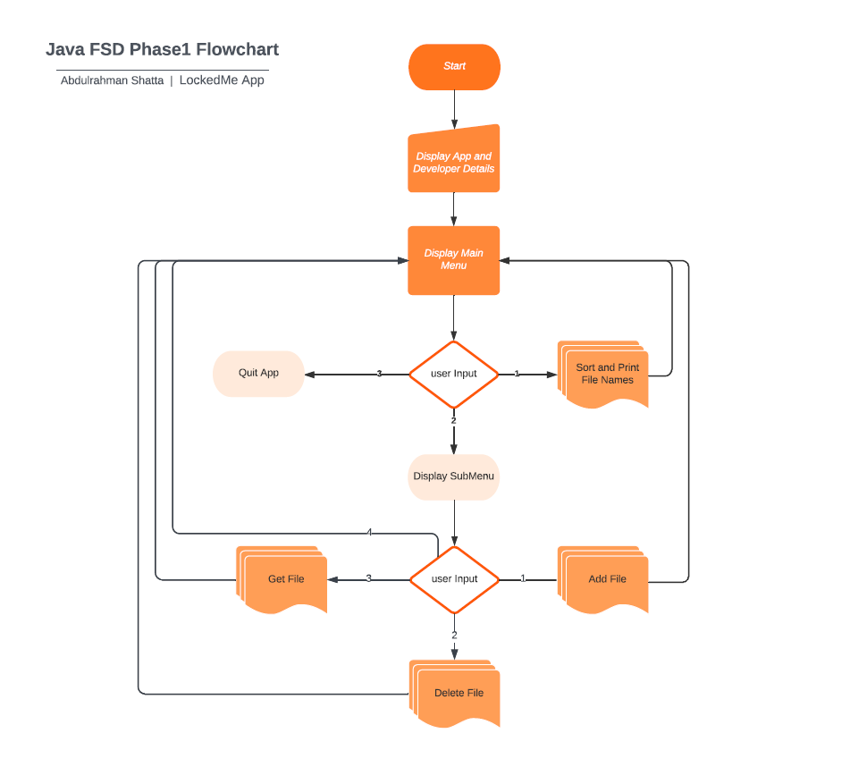

**Conclusion:**

To enhance our application we can add more features and options in the menu also we can ad Graphical User Interface GUI to the application to be more user friendly, Unique Selling Points USP is that our application is well structured and editable so we can edit to add new features to it easily.